Mental Health Prediction using PHQ-9, GAD-7 and SAS-SV scales using Machine Learning

# Nimit Garg

*Department of Computer Science and Engineering*

*Chandigarh University*

Mohali, India

[21bcs4626@cuchd.in](mailto:21bcs4626@cuchd.in)

# Reyaan Sachdeva

*Department of Computer Science and Engineering*

*Chandigarh University*

Mohali, India [21bcs5381@cuchd.in](mailto:21bcs5381@cuchd.in)

***Abstract*—Depression and anxiety in particular continue to be major obstacles for college students dealing with mental health difficulties. This population uses smart phones extensively, therefore there’s a rising interest in learning more about the connection between usage patterns and the impact on mental health. The purpose of this research is to evaluate depression and anxiety symptoms in college students by utilizing machine learning techniques and data gathered from many characteristics, such as mental health indicators and smart phone use. The study’s data set include social, mobile phone usage trends, and demographic information. measures for engagement and well- being gathered from college students. Our particular area of research is the prediction of scores on three commonly used mental health rating scales: the Generalized Anxiety Disorder-7 (GAD-7), the Patient Health Questionnaire-9 (PHQ-9), and Smart phone Addiction Scale - Short Version (SAS-SV). We employ machine learning algorithms, such as Support Vector Machine (SVM), Random Forest, and Gaussian Naive Bayes, to predict SAS, PHQ-9, and GAD-7 scores from the given data set in order to meet our objectives. Measures of social engagement, anxiety/stress levels, and general well-being are among the tools used to train these models. The purpose of the study is to gather data regarding the association between college students’ smart phone usage habits and mental health outcomes. We attempt to find potential trends and connections between mobile phone usage patterns and indicators of mental health by evaluating the data and utilizing machine learning techniques. The results of this study can guide the creation of focused interventions and support plans meant to enhance the well being of students. In summary, this study advances knowledge of the intricate relationship between college students’ smart phone use and mental health consequences. Our goal is to extract meaningful insights from machine learning approaches that might drive evidence-based interventions and direct future research to enhance student mental health.**

***Index Terms*—Mental health, PHQ-9, GAD-7, SAS**

1. **Introduction**
2. ***Background***

Mental health issues have emerged as a significant concern among university students worldwide. The transition to university life, coupled with academic pressures and social

# Vansh Garg

*Department of Computer Science and Engineering Chandigarh University*

Mohali, India

[21bcs4548@cuchd.in](mailto:21bcs4548@cuchd.in)

challenges, often exacerbates stress levels. Moreover, the ubiquitous use of smart phones among this demographic introduces a new dimension to mental health concerns. Understanding the intricate relationship between smart phone usage patterns and mental health outcomes is crucial for developing effective interventions and support strategies within university communities.

Given the prevalence of smart phones and their impact on daily life, elucidating how smart phone usage affects mental well-being can inform targeted approaches to promote students’ overall health and academic success. The study focuses on leveraging machine learning techniques to analyze data collected from university students, with a specific emphasis on smart phone usage behaviors and their association with depression and anxiety symptoms. By examining various attributes such as demographic information, smart phone usage patterns, social engagement, and well-being metrics, we aim to explore the intricate interplay between these factors and mental health indicators.

The Patient Health Questionnaire-9 (PHQ-9), Generalized Anxiety Disorder-7 (GAD-7), and Smart phone Addiction Scale (SAS) are widely used screening tools for assessing depression and anxiety symptoms. By predicting scores on these scales based on the provided data set, we seek to uncover insights into the prevalence and severity of depression and anxiety among university students.

1. ***System Description***

**SAS-SV (Smart phone Addiction Scale - Short Version):** A self-report tool called the Smart phone Addiction Scale (SAS) is used to evaluate the symptoms of smart phone ad- diction. It has 20 items that assess how severe smart phone addiction behaviour have been during the previous week. On a 4-point metric from 1 (strongly disagree) to 4 (strongly agree), participants score each topic. Higher scores indicate more severe symptoms of smart phone addiction. The total score can vary from 20 to 80.In this instance, the eight items are rated on a 4-point scale from 1 (strongly disagree) to 4

(strongly agree), with a possible total score of 8–32. We have determined that those who score higher than 18 on these scales are likely to be smart phone addicts.

**PHQ-9 (Patient Health Questionnaire-9):** A popular screening tool for evaluating depressive symptoms is PHQ-9. The instrument comprises nine items that gauge the occurrence of depressed symptoms during the previous fortnight. Every question has a score ranging from 0 to 3, where higher scores correspond to more severe depression. A total score of 0–27 can be obtained; mild, moderate, moderately severe, and severe depression are represented by values of 5, 10, 15, and 20, respectively.

**GAD-7 (Generalized Anxiety Disorder-7):** A quick test to gauge the severity of generalized anxiety disorder (GAD) is the GAD-7. It is made up of seven questions that gauge how frequently anxious symptoms have occurred during the previous two weeks. Every question has a score ranging from 0 to 3, where higher values correspond to more severe anxiety. A total of 0 to 21 can be obtained; mild, moderate, and severe anxiety are represented by scores of 5, 10, and 15, respectively.

1. **Literature Review**

Anxiety was a common psychiatric co morbidity among migraine sufferers, according Jong-Geun Seo et al. (2015) [1]. Anxiety screening has shown to be a helpful method for locating anxiety episodes in migraines that could have gone unnoticed in the past. It has been established that the GAD-7 and GAD-2 are simple screening instruments for determining whether migraineurs have generalized anxiety disorder (GAD). It was thought to be crucial to identify anxiety in migraine sufferers as soon as possible and to start the right treatment as soon as the condition was identified.

Zhong, Qiu-Yue et al. (2015) [2]Participants in the GAD-7 study are asked to score how often each of these seven primary symptoms has bothered them during the past two weeks. Response groups ”not at all,” ”several days,” ”more than half the days,” and ”nearly every day” are those that received scores of 0, 1, 2, and 3. The overall score on the GAD-7 ranges from 0 to 21. Among primary care patients and the general public, the GAD-7 has demonstrated good internal consistency, test- retest reliability, convergent, construct, criterion, and factorial validity.

PHQ-9 is a self-administered screening instrument that was used to evaluate the severity of depressive symptoms, according to Yue Sun et al. (2020) [3]. In contrast to other depression measures, the PHQ-9 has nine items that are unique to major depressive disorder (MDD) as defined by the Diagnostic and Statistical Manual of Mental Disorders, Fourth Edition (DSM- IV). In the questionnaire, participants are asked to rate the frequency with which any of the nine issues bothered them in the last two weeks. The PHQ-9 had three possible scores for each item: 0 for not at all, 1 for several days, 2 for more than a week, and 3 for almost every day. Scores of 5 to 9 indicate mild depression, whereas scores of 10 to 14 indicate major depression. The PHQ-9 total score ranges from 0 to 27, 15–19 as moderately severe depression; 20 as severe depression).

Al-2020 Tannin et al. [4]This study looks into information gathered from university students via a questionnaire that probably included questions on their usage habits of smart- phones and their perceptions of their symptoms of addiction. Interventions and support services targeted at encouraging healthy smart phone usage habits might be informed by knowledge of the prevalence and contributing factors of smart phone addiction among college students.

According to Eisenberg et al. (2012) [5], the study looks at academic achievement, access to mental health care, and demographic characteristics in addition to determining the prevalence of mental health disorders among college students. In order to effectively address mental health challenges, it can be useful to identify variations among subgroups and campuses in order to provide targeted treatments and support resources.

The aim of this study was to examine observational studies on the connection between mobile phone use and mental health from a behavioral or psychological standpoint, as reported by Sara Thomee et al. (2018) [6]. Research looking into the behavioral or psychological components of using a mobile phone has found connections to detrimental effects on mental health. To precisely ascertain the mechanisms and causal orientations of links, more excellent study was required.

The way individuals interacted was altered by the widespread use of information and communication techno- logy, according to Milka et al. (2020) [7]. People faced new challenges adjusting to the rapid improvements in technology as their worldview changed. Technology use, including social media, video games, mobile phones, and the Internet, has changed how people behave, and it has even resulted in technological addiction.

A study on diagnostic accuracy was conducted at a university in the US Pacific Northwest in two primary care clinics. Seventy-one patients, who were 65 years of age or older, completed the PHQ-9, GDS, and SCID. The sensitivity, specificity, area under the receiver operating characteristic (ROC) curve, and likelihood ratios (LRs) for major depression alone and with minor depression were assessed for the PHQ-9, PHQ-2, and 15-item GDS.

Phelan and associates (2010) In two primary care clinics at a university in the US Pacific Northwest, a study on diagnostic accuracy was conducted. Seventy-one patients, who were 65 years of age or older, completed the PHQ-9, GDS, and SCID. The sensitivity, specificity, area under the receiver operating characteristic (ROC) curve, and likelihood ratios (LRs) for major depression alone and with minor depression were assessed for the PHQ-9, PHQ-2, and 15-item GDS.

1. **Proposed System**

The suggested approach focuses on the relationship between smart phone usage habits and symptoms of anxiety and sadness in order to create a complete framework for evaluating and treating mental health issues among college students. Data collection, machine learning models, feature selection, prediction and analysis, intervention techniques, evaluation, and

feedback are some of the main parts of the system. Surveys and questionnaires will be used to gather data on mental health indicators, smart phone using trends, and demographics. The gathered data will be analyzed by machine learning algorithms to forecast scores on standardized tests like the SAS, GAD-7, and PHQ-9.

Feature selection approaches will be used to identify relevant traits linked to outcomes related to mental health and smart phone usage. The analysis of predicted anxiety and depression scores will look for trends or connections with smart phone usage habits. Targeted intervention methods will be created to support students’ mental health in light of these findings. Persistent assessment and input will guarantee continuous enhancement and modification of the system to fulfil the changing requirements of college pupils.

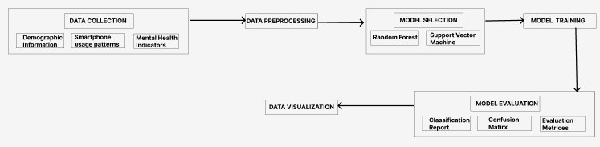**Fig. 1.** Proposed Model of the Project

1. **Methodology**

The study collected information from 1024 participants, including instructors and students from a range of university academic programme. 24 records were eliminated following an initial screening procedure because of errors or inconsistencies. The age range of the participants was 18–46 years old. With 471 participants, the gender distribution was slightly skewed towards men, with the remainder participants being women. A smaller cohort of teachers and 618 pupils were also included in the data set. The attendees came from a range of academic backgrounds, with the most common streams being business administration, marketing, and computer science.

***A. Flow of the Model***

Here is the methodology of the Proposed Model:

* **Data Collection:** Gathered data from 1024 university Stu- dents and faculty across multiple disciplines. Excluded 24 records due to data quality issues. Final data set consists of 1000 entries with age ranging from 18 to 46 years. Gender distribution: 471 males, 529 females.
* **Data preprocessing:** Handled missing values, encoded categorical variables, and scaled features.
* **Model Selection:** Chose Random Forest and Support Vector Machine (SVM) algorithms for classification tasks.
* **Data Visualization:** Utilized histograms, heat maps, and correlation matrices to visualize relationships between variables.
* **Model Evaluation:** Assessed model performance using classification reports, confusion matrices, and evaluation metrics (accuracy, precision, recall, F1-score).

- **Model Validation:** Employed holdout validation and k-fold cross-validation for model validation. Optimized models based on validation results to ensure reliability.

Below is the visualization of the steps which need to be taken care of to complete this research and gain some output.

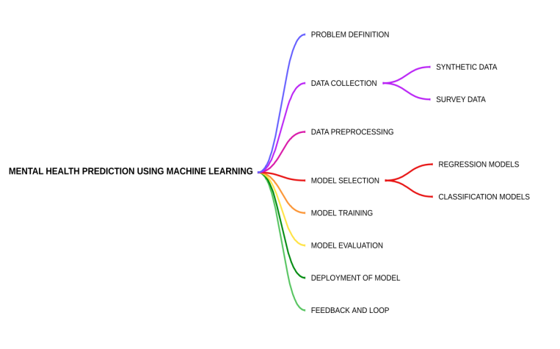

**Fig. 2.** Methodology in Machine Learning

***B. Feature Analysis***

* **Screen Time:** As our project's primary focus, we are examining users' screen times to learn more about their phone usage patterns.
* **App Categories:** We will examine the various app categories that users utilize in order to identify inappropriate usage that should be avoided in order to enhance mental health.
* **Field of Study:** This is crucial since it indicates how much of a user should know. For example, in computer science and marketing, for example, use will be higher than in other fields, which helps with model construction.
* **Expected Screen Time Usage:**  We have calculated a value names expected screen time usage which depends on field of study like for marketing , business and computer science fields the expected screen time is supposed to be high as compared to other fields.
* **Categorized Sleep Duration:** We have also categorized the sleep duration in multiple ranges like below 5 hours, 5-9 hours and above 9 hours to make it easy to apply conditional changes.
* **Correlation Heatmaps:** We will be using different correlation matrices and heat maps to visualize the different features and how they are connected to each other and when these different features are combined they are more likely to act better when used in a model.
* **Continuous Refinement:** At last continuous feedback from users and iterative analysis of features would make model more and more better in the future and will be applicable in different real time application.

Demographic Attributes like name, age, gender, etc. , Different binary attributes related to these questionnaires like If we talk about the SAS-SV we have used different demographic attributes like name, age, gender, and then attributes like Screen Time, Social Engagement,etc.

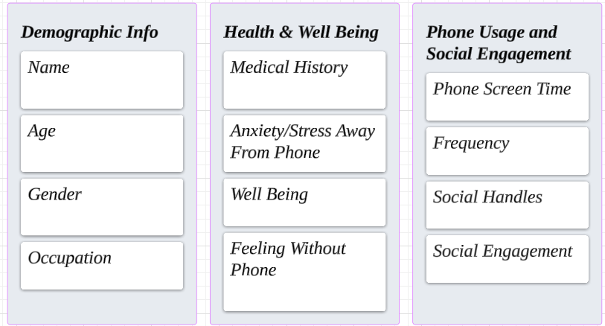

**Fig. 3:** Data Attributes Analysis

1. **Result and Implementation**

In terms of predicting the impact on mental health according to smart phone usage patterns, the developed models fared very well. The PHQ-9 data set’s Cronbach’s Alpha score was found to be 0.86, indicating that the survey items had a good level of internal consistency. ”Severe depression” was predicted by the SVM classifier with a 94% accuracy, 93% precision, and 100% recall rate. Strong precision and recall scores across various depression categories further demonstrated the model’s efficacy in identifying varying degrees of depression.

The relationships between different variables and mental health scores were revealed through correlation heat maps and other visualizations. The heat map demonstrated substantial links between particular smart phone usage habits and indices of mental health, highlighting areas that warrant further investigation and intervention.

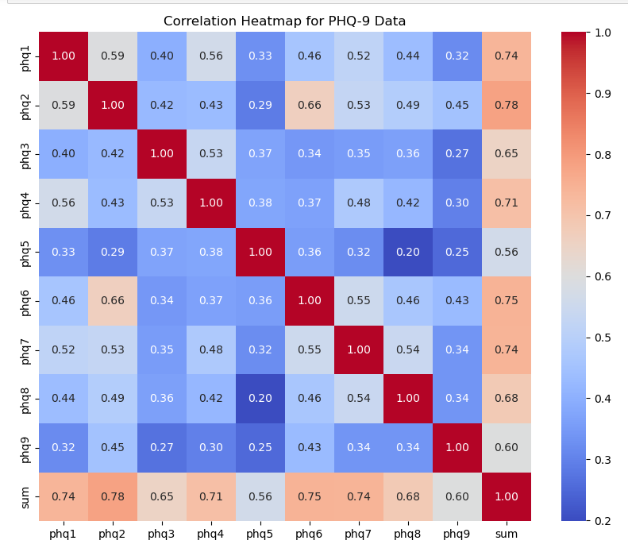

**Fig. 4:** Correlation Matrix for PHQ-9 Data

Based on the PHQ-9 ratings, the SVM algorithm successfully divided the 600 patients into discrete depression categories. 189 patients are classified as having "Mild depression," 101 as having "Minimal depression," 177 as having "Moderate depression," 82 as having "Moderately severe depression," and 34 as having "Severe depression" according to the breakdown. And at last 17 patients fit the description of "No depression."

For the SAS-SV data set, the Cronbach’s Alpha value was found to be 0.82, indicating a satisfactory level of scale dependability. The SVM classifier made a 100% accurate distinction between users who were ’ADDICTED’ and those who were ’NOT ADDICTED’ based on their usage patterns of smart phones.

When utilizing the SAS-SV scale to identify people according to their degree of smart phone addiction, the SVM model obtained 100% accuracy. A total of 600 participants were classified; of these, 328 were classified as 'ADDICTED' and 272 as 'NOT ADDICTED,' demonstrating how well the model categorized the data.

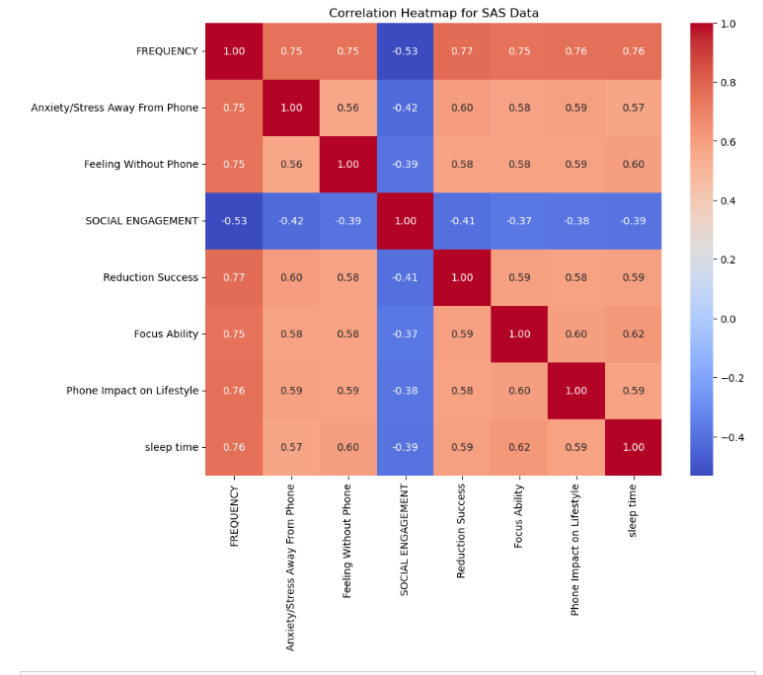

**Fig 5:** Correlation Matrix for SAS-SV Data

Based on the model predictions and visual analysis, targeted interventions can be implemented to support the mental health of university students. Furthermore, by in- integrating these prediction models with the university’s present counselling and health services, students in need can receive timely support and resources.

Additionally, the significance of continuous data collecting and model improvement was emphasized. Constantly tracking smart phone usage trends and mental health outcomes can help to improve therapeutic tactics and provide important insights for future studies.

To further improve the predicted accuracy and usefulness of the models, future study can investigate the integration of additional variables, such as social contacts and academic success.

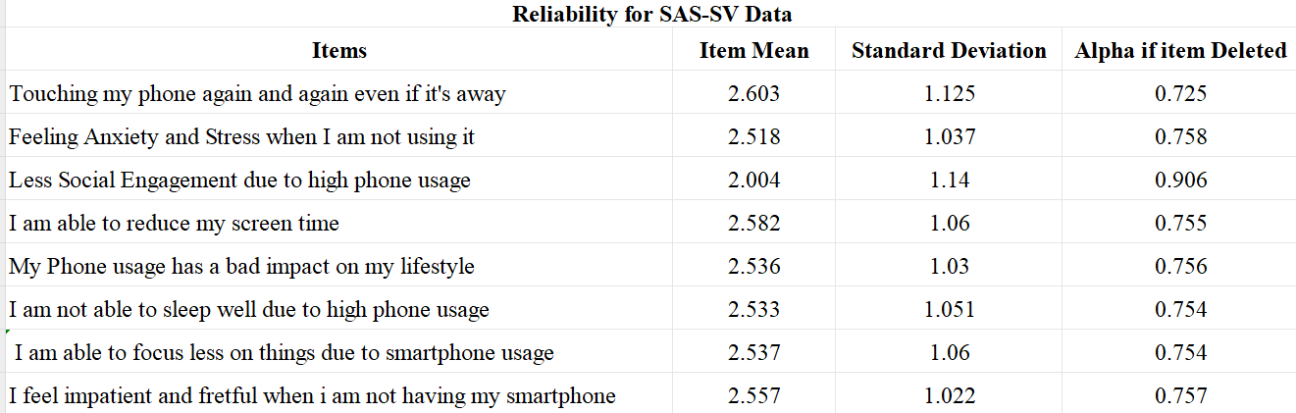

**Table 1**: Reliability Analysis of SAS-SV

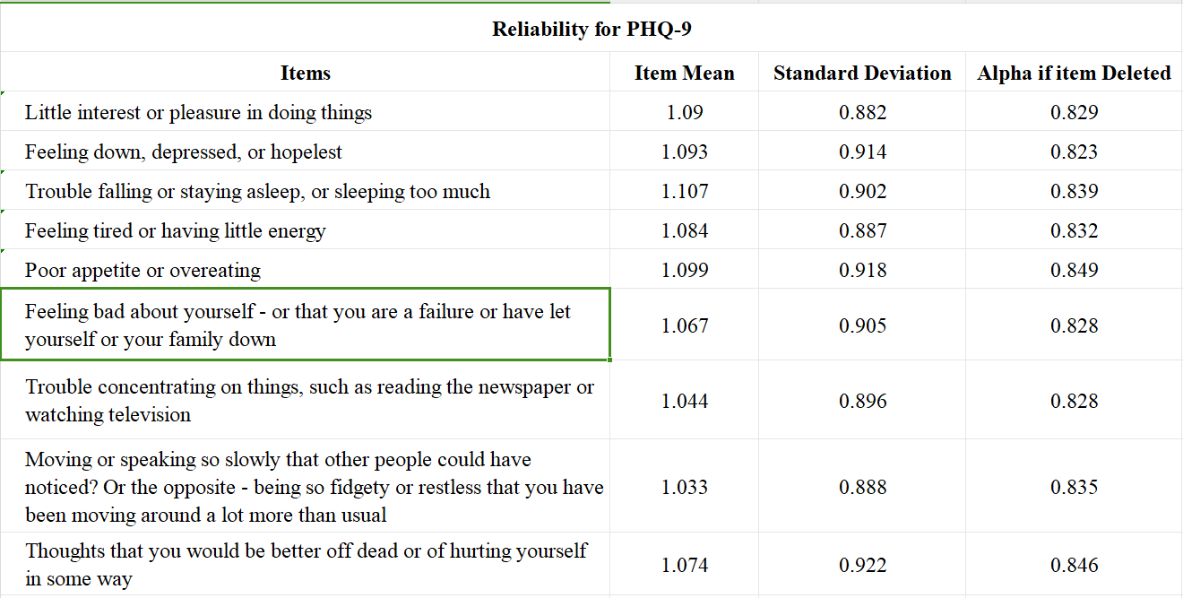

**Table 2**: Reliability Analysis of PHQ-9

1. **CONCLUSION**

**Predictive Modelling for Mental Health Assessment:** Using machine learning approaches, we investigated predictive models for mental health assessment with three commonly used scales: the Generalized Anxiety Disorder (GAD-7) scale, the PHQ-9 scale for depression severity, and the SAS-SV scale for smart phone addiction.

**Clinical Utility and Implications:** Early intervention and individualized treatment planning may benefit from the prediction models' promising performance in identifying and evaluating mental health disorders.

**Prospects and Matters to Be Considered:** Even though our study provides insightful information, more investigation is necessary to improve the model's interpretability, generalization, and accuracy. In order to provide a thorough mental health assessment, future work may concentrate on improving predicting algorithms, testing models across a range of demographics, and adding more psychometric scales.

**Future Directions and Considerations:** Although our study provides insightful information, more research is necessary to improve the accuracy, generalization, and interpretability of the model. In order to provide a thorough mental health assessment, future work may concentrate on improving predicting algorithms, testing models across a range of demographics, and adding more psychometric scales. Furthermore, investigating how different demographic variables—like age, gender, and educational attainment—affect mental health outcomes can offer a more complex picture of personal vulnerabilities and resilience elements.

**Integration with Clinical Practice:** By utilizing these predictive models in clinical practice, evaluation procedures can be streamlined, risk assessment can be aided, and focused interventions can be made easier. Health care providers may be able to more effectively distribute resources thanks to their integration, guaranteeing that those in need receive timely and appropriate care.

**References**

1. Seo, J.G. and Park, S.P., 2015. Validation of the Generalized Anxiety Disorder-7 (GAD-7) and GAD-2 in patients with migraine. The journal of headache and pain, 16, pp.1-7.
2. Zhong, Q.Y., Gelaye, B., Zaslavsky, A.M., Fann, J.R., Rondon, M.B., Sa´nchez, S.E. and Williams, M.A., 2015. Diagnostic validity of the generalized anxiety disorder-7 (GAD-7) among pregnant women. PloS one, 10(4), p.e0125096.
3. Sun, Y., Fu, Z., Bo, Q., Mao, Z., Ma, X. and Wang, C., 2020. The

reliability and validity of PHQ-9 in patients with major depressive disorder in psychiatric hospital. BMC psychiatry, 20, pp.1-7.

1. Spitzer, R. L., Kroenke, K., Williams, J. B., Lo¨we, B. (2006). A brief measure for assessing generalized anxiety disorder: The GAD-7. Archives of Internal Medicine, 166(10), 1092–1097.
2. Eisenberg, D., Hunt, J., Speer, N. (2012). Mental health in American colleges and universities: Variation across student subgroups and across campuses. Journal of Nervous and Mental Disease, 200(5), 1–7.
3. S. Arefin, R. Islam, M. A. A. Mustafi, S. Afrin, and N. Islam, “Impact of smartphone addiction on business students’ academic performance: a case study,” Independent Journal of Management & Production, vol. 8, no. 3, pp. 955–975, 2017.
4. Thome´e, S., 2018. Mobile phone use and mental health. A review of the research that takes a psychological perspective on exposure. International journal of environmental research and public health, 15(12), p.2692.
5. Escalera-Cha´vez, M.E. and Rojas-Kramer, C.A., 2020. SAS-SV Smart- phone Addiction Scale in Mexican University Students. Education Research International, 2020, pp.1-10.
6. Ciechanowski P, Wagner E, Schmaling K, Schwartz S, Williams B, Diehr P, Kulzer J, Gray S, Collier C, LoGerfo J: Community-integrated home-based Phelan et al. BMC Family Practice 2010, 11:63 http://www.biomedcentral.com/1471-2296/11/63 Page 8 of 9 depression treatment in older adults: a randomized controlled trial. JAMA 2004, 291:1569-1577.
7. Ackermann RT, Williams JW Jr: Rational treatment choices for non-major depressions in primary care: an evidence-based review. J Gen Intern Med 2002, 17:293-301.